CO-4 ASSISSMENT-4
TASK 1 – MEANING REPRESENTATION AND LANGUAGE STRUCTURE
1.1 IDENTIFY MEANING COMPONENTS
Given Sentence: "Maya gave Ravi a book yesterday."
Meaning Components:
Component | Identification
Entity 1 | Maya
Entity 2 | Ravi
Entity 3 | Book
Event | Giving
Agent | Maya
Recipient | Ravi
Theme | Book
Time | Yesterday
Linguistic Form:
The sentence follows Subject + Verb + Indirect Object + Direct Object + Time.
Meaning Conveyed:
Maya performed the action of giving a book to Ravi on the previous day.
1.2 COMPARE MEANING REPRESENTATIONS
A. Conceptual / Event Structure
Event: GIVING
- Agent: Maya
- Action: Give
- Recipient: Ravi
- Object: Book
- Time: Yesterday
This representation identifies the main event and its participants.
B. Structured Frame Representation
Slot | Value
Event | Giving
Agent | Maya
Recipient | Ravi
Theme | Book
Time | Yesterday
This frame stores information in separate slots, making it easy for a computer to process.
Comparison:
The event structure shows the relationship between the action and participants. The frame representation stores the same information in an organized format. Both represent the sentence meaning, but the frame makes individual information fields more explicit.
1.3 MEANING STRUCTURE AND AMBIGUITY
Word order helps identify the grammatical structure, while semantic roles identify the actual participants in an event.
Alternative Sentence:
"Yesterday, Ravi was given a book by Maya."
Semantic Representation:
- Agent: Maya
- Recipient: Ravi
- Theme: Book
- Time: Yesterday
Although the sentence structure changes, its core meaning remains the same.
1.4 DESIGN DEFENCE
The event and frame representations are suitable for computer systems because they organize information into meaningful fields. They identify the agent, recipient, object and time separately. A computer can store, search and process these fields easily. Unlike a simple paraphrase, these representations provide structured information that can be used in question answering and information retrieval systems.
TASK 2 – FIRST ORDER PREDICATE CALCULUS
2.1 DEFINE THE LOGICAL VOCABULARY
First Order Predicate Calculus (FOPC) is a method used to represent statements using logical symbols, predicates and quantifiers.
Predicates:
Predicate | Meaning | Argument Order
Student(x) | x is a student | x
Course(y) | y is a course | y
Instructor(z) | z is an instructor | z
Enrolled(x,y) | x is enrolled in y | Student, Course
Teaches(z,y) | z teaches y | Instructor, Course
Passed(x,y) | x passed y | Student, Course
Constants:
- DrRao – Represents Dr. Rao.
- NLP – Represents the NLP course.
Variables:
- x – Student
- y – Course
- z – Instructor
Logical Symbols:
- ∀ – For all
- ∃ – There exists
- ∧ – AND
- → – Implies
- ¬ – NOT
2.2 TRANSLATE NATURAL LANGUAGE INTO LOGIC
(i) Every student is enrolled in at least one course.
Formula:
∀x [Student(x) → ∃y (Course(y) ∧ Enrolled(x,y))]
Explanation: Every student must be enrolled in at least one course.
(ii) Some student passed every course taught by Dr. Rao.
Formula:
∃x [Student(x) ∧ ∀y ((Course(y) ∧ Teaches(DrRao,y)) → Passed(x,y))]
Explanation: At least one student has passed all courses taught by Dr. Rao.
(iii) No instructor teaches every course.
Formula:
∀z [Instructor(z) → ∃y (Course(y) ∧ ¬Teaches(z,y))]
Explanation: Every instructor has at least one course that they do not teach.
2.3 INTERPRET AND CHECK THE FORMULAE
Consider the formula:
∀x [Student(x) → ∃y (Course(y) ∧ Enrolled(x,y))]
Scope Explanation:
The universal quantifier (∀x) applies to every student. The existential quantifier (∃y) means that each student has at least one course in which they are enrolled.
Quantifier Order Example:
Formula 1:
∀x ∃y Enrolled(x,y)
Meaning: Every student is enrolled in some course.
Formula 2:
∃y ∀x Enrolled(x,y)
Meaning: There is one particular course in which every student is enrolled.
Counterexample:
Consider:
- Students: Asha and Ravi
- Courses: NLP and AI
- Asha is enrolled in NLP.
- Ravi is enrolled in AI.
In this example, Formula 1 is true because each student has a course.
Formula 2 is false because there is no single course in which both students are enrolled.
Therefore, changing quantifier order changes the meaning.
2.4 LOGICAL CONSISTENCY
Statements:
- Every student passed NLP.
- There is a student who did not pass NLP.
Answer:
These two statements cannot both be true in the same logical model.The first statement says that all students passed NLP. The second statement says that at least one student failed NLP.Both statements contradict each other.
Therefore, the statements are logically inconsistent.

TASK 3 – LINGUISTICALLY RELEVANT CONCEPTS AND SYNTAX-DRIVEN SEMANTIC ANALYSIS
Given Sentence:
"The experienced researcher saw the student with the telescope."
3.1 IDENTIFY LINGUISTICALLY RELEVANT CONCEPTS
Concept | Identification
Entity 1 | Researcher
Entity 2 | Student
Action | Saw
Modifier | Experienced
Instrument | Telescope
Relation | Researcher sees student
Prepositional Phrase | With the telescope
Explanation:
The researcher is the person performing the seeing action. The student is the person being seen. The word experienced describes the researcher. The phrase "with the telescope" creates ambiguity because it may describe the instrument used for seeing or the student having the telescope.
3.2 SYNTAX-TO-SEMANTICS MAPPING
The phrase "with the telescope" has two possible interpretations.
Interpretation 1 – Telescope as an Instrument
The researcher used a telescope to see the student.
Structure:
- Subject: Experienced researcher
- Verb: Saw
- Object: Student
- Instrument: Telescope
Semantic Representation:
SEE (Researcher, Student, Telescope)
Interpretation 2 – Telescope as an Object Associated with the Student
The researcher saw a student who had a telescope.
Structure:
- Subject: Experienced researcher
- Verb: Saw
- Object: Student with telescope
Semantic Representation:
SEE (Researcher, Student)
HAS (Student, Telescope)
Syntax-Driven Procedure:
- Identify the subject and verb.
- Identify the object of the sentence.
- Identify the prepositional phrase.
- Check whether the phrase is attached to the verb or noun.
- Generate the corresponding semantic representation.
3.3 SEMANTIC COMPOSITION
The sentence meaning is developed step by step:
- "Researcher" identifies the main person.
- "Experienced" describes the researcher.
- "Saw" represents the action.
- "Student" identifies the person being seen.
- "With the telescope" provides additional information.
The two interpretations diverge when the system attaches the prepositional phrase either to the verb "saw" or to the noun "student".
3.4 FAILURE ANALYSIS
Error 1: Incorrect Attachment
The parser may attach the telescope to the student instead of treating it as an instrument.
Validation: Check the attachment using the sentence structure and surrounding context.
Error 2: Incorrect Semantic Role
The system may identify the student as the person performing the seeing action.
Validation: Check the subject, verb and object relationships before assigning semantic roles.
These checks help improve the accuracy of sentence interpretation.
TASK 4 – LEXEMES, SENSES AND WORD SENSE DISAMBIGUATION
4.1 LEXEMES AND SENSES
A lexeme is the basic vocabulary unit that represents a word and its related forms. A word form is the actual form used in a sentence. A sense is the particular meaning of a word in a context.
Different Senses of BANK:
Sentence | Word Form | Part of Speech | Meaning
Nila deposited cash at the bank. | Bank | Noun | Financial institution
They sat on the bank of the river. | Bank | Noun | River side
The pilot banked the aircraft to the left. | Banked | Verb | Tilted the aircraft
The noun and verb forms belong to different grammatical uses of the word BANK.
4.2 DESIGN A WORD SENSE DISAMBIGUATION METHOD
Word Sense Disambiguation (WSD) identifies the correct meaning of a word based on its surrounding context.
Proposed Method: Context-Based WSD
Input:
A sentence containing the word BANK.
Candidate Senses:
- Financial institution.
- Side of a river.
- Tilting an aircraft.
Context Features:
- Nearby words.
- Verbs and nouns.
- Part of speech.
- Meaning of surrounding words.
Procedure:
- Receive the input sentence.
- Identify the target word BANK.
- Extract surrounding words.
- Generate possible meanings.
- Compare context words with each candidate meaning.
- Select the meaning with the strongest contextual match.
- Display the selected meaning.
Output: Correct meaning of the word BANK.
4.3 TEST THE METHOD
Sentence | Context Evidence | Selected Sense
Nila deposited cash at the bank. | Deposited, cash | Financial institution
They sat on the bank of the river. | River, sat | River side
The pilot banked the aircraft to the left. | Pilot, aircraft | Aircraft tilting
We visited the bank to open an account. | Account, visited | Financial institution
Possible Failure:
The system may fail when a sentence has insufficient context.
Example: "She went to the bank."
The system cannot confidently identify whether BANK means a financial institution or a river side.
4.4 EVALUATION
A small labelled test set can be created with 10 sentences containing different uses of BANK.
Sample Test Set:
Sentence | Actual Sense
He deposited money in the bank. | Financial
She opened a bank account. | Financial
The bank approved the loan. | Financial
They walked along the river bank. | River
The boat reached the bank. | River
We sat near the bank. | River
The pilot banked the aircraft. | Aircraft
The plane banked sharply. | Aircraft
The aircraft banked left. | Aircraft
She visited the bank. | Financial
Suppose the system correctly identifies 9 out of 10 sentences.
Accuracy Formula:
Accuracy = (Correct Predictions / Total Predictions) × 100
Accuracy = (9 / 10) × 100
Accuracy = 90%
Explanation:
Accuracy measures how many predictions are correct. However, high accuracy on a balanced test set does not guarantee perfect performance in real-world situations. Real text may contain unfamiliar words, missing context and multiple meanings.
TASK 5 – INFORMATION RETRIEVAL AND SEMANTIC MATCHING
5.1 QUERY AND DOCUMENT REPRESENTATION
Given Query:
"Methods for finding the meaning of ambiguous words."
Central Concepts:
- Word meaning
- Ambiguity
- Context
- Word Sense Disambiguation
- Semantic analysis
Semantic Intent:
The user wants to find methods that identify the correct meaning of words having multiple meanings.
Query Representation:
Q = {Word Meaning, Ambiguity, Context, WSD, Semantic Analysis}
Document Representation:
Each document can be represented using important keywords, concepts and semantic meanings. This helps the search system retrieve documents based on their actual meaning.
5.2 LEXICAL VERSUS SEMANTIC RETRIEVAL
Keyword Matching:
Keyword matching searches for documents containing the exact words in the query.
Advantages:
- Simple to implement.
- Fast searching.
- Useful for exact keyword searches.
Limitation:
It may miss documents that use different words but discuss the same concept.
Semantic Retrieval:
Semantic retrieval understands the meaning of the query and compares it with document concepts.
Example of a relevant document:
"Contextual methods for identifying the correct interpretation of words."
This document may not contain the exact phrase "ambiguous words", but its meaning is related to the query.Therefore, semantic retrieval can identify it as relevant.
5.3 RANKING DESIGN
A ranking system can use three important signals:
- Keyword Relevance – Checks matching words.
- Concept Similarity – Checks similarity between query and document meanings.
- Context Match – Checks whether the document discusses the intended topic.
Ranking Formula:
Final Score = (0.3 × Keyword Score) + (0.5 × Semantic Score) + (0.2 × Context Score)
Example:
Document | Keyword Score | Semantic Score | Context Score | Final Score
D1 | 0.9 | 0.9 | 0.8 | 0.88
D2 | 0.4 | 0.9 | 0.9 | 0.75
D3 | 0.8 | 0.3 | 0.4 | 0.47
Ranking:
- D1 – 0.88
- D2 – 0.75
- D3 – 0.47
Document D2 receives a good score because it has strong semantic similarity even though its keyword score is low.
5.4 EVALUATION AND ERROR ANALYSIS
Precision measures how many retrieved documents are relevant.
Recall measures how many relevant documents are successfully retrieved.
Example:
Suppose:
- Total relevant documents = 5
- Retrieved documents = 4
- Relevant retrieved documents = 3
Precision:
Precision = Relevant Retrieved Documents / Total Retrieved Documents
Precision = 3/4 = 0.75
Precision = 75%
Recall:
Recall = Relevant Retrieved Documents / Total Relevant Documents
Recall = 3/5 = 0.60
Recall = 60%
Semantic Retrieval Error:
The system may retrieve a document about general language translation because it is related to language meaning but does not explain word sense disambiguation.
Improvement:
Use context matching and concept-based filtering to remove documents that do not answer the actual query.
TASK 6 – INTEGRATED SEMANTIC ANALYSIS CHALLENGE
Given Sentence:
"I saw her duck near the bank, and it was closed."
STAGE 1 – INTERPRET THE PROBLEM
The sentence contains multiple ambiguous words.
Possible Ambiguities:
- Duck may refer to a bird or the action of lowering the head.
- Bank may refer to a financial institution or a river side.
- It may refer to the duck or the bank.
The system needs additional context to identify the intended meanings.
STAGE 2 – BUILD CANDIDATE INTERPRETATIONS
Interpretation 1 – Duck as a Bird and Bank as a River Side
Meaning:
The speaker saw a bird belonging to her near a river bank.
Semantic Representation:
- Agent: Speaker
- Action: Saw
- Possessor: Her
- Object: Duck (Bird)
- Location: River Bank
Structured Representation:
SEE (Speaker, Duck)
HAS (Her, Duck)
NEAR (Duck, RiverBank)
Interpretation 2 – Duck as an Action and Bank as a Financial Institution
Meaning:
The speaker saw her lower her body near a financial institution, and the institution was closed.
Semantic Representation:
- Agent: Speaker
- Action: Saw
- Person: Her
- Action performed: Ducking
- Location: Financial Bank
- Status: Closed
Structured Representation:
SEE (Speaker, Her)
PERFORMS (Her, DuckAction)
NEAR (Her, FinancialBank)
CLOSED (FinancialBank)
STAGE 3 – SYNTAX-DRIVEN ANALYSIS AND WSD
The system first analyses the sentence structure and identifies the grammatical roles.
Procedure:
- Identify the subject and verb.
- Identify the ambiguous word DUCK.
- Generate the bird and action meanings.
- Analyse the word BANK.
- Generate the financial and geographical meanings.
- Use surrounding words and context to compare the candidate meanings.
- Identify what the pronoun IT refers to.
Additional Context:
Information about the situation, such as whether the speaker was near a river or a financial institution, would help resolve the ambiguity.
If the meaning remains unclear, the system should retain both interpretations or ask the user for clarification.
STAGE 4 – INFORMATION RETRIEVAL TRACE
After selecting an interpretation, the system creates a semantic search query.
Selected Interpretation:
Assumption: The sentence refers to a financial bank, and IT refers to the bank.
Query Representation:
{Financial Institution, Bank Closing, Business Hours, Bank Services}
Candidate Documents:
 | Description | Relevance
D1 | Why banks close during non-working hours | High
D2 | Bank account opening and closing procedures | High
D3 | Different types of river banks | Low
D4 | Information about ducks and water birds | Low
Ranking:
- D1 – Why banks close during non-working hours.
- D2 – Bank account opening and closing procedures.
- D3 – Different types of river banks.
- D4 – Information about ducks and water birds.
The system selects documents related to the financial meaning of BANK. It avoids selecting documents that only contain the word bank but discuss river geography.
STAGE 5 – CHALLENGE AND REFINE
Misleading Context:
Suppose the sentence is "I saw her duck near the bank" without any additional information.
The system may select the wrong meaning because both DUCK and BANK have multiple senses.
Expected Response:
The system should identify uncertainty and retain alternative interpretations instead of making an unsupported decision.
Improvement:
Use additional sentence context, grammatical analysis and semantic similarity to improve the selection of the correct meaning.

CONCLUSION
Semantic analysis helps NLP systems understand the actual meaning of natural language sentences. This assignment explains meaning representation, predicate logic, syntax-driven analysis, lexemes, word sense disambiguation and semantic information retrieval. It also demonstrates how different meanings can be represented and evaluated using structured methods. These techniques help develop intelligent NLP systems that can interpret language more accurately and retrieve relevant information based on context and meaning.
PART2:SEMANTIC SYSTEMS ENGINEERING: ANALYSE, REPRESENT, TEST, DISAMBIGUATE & RETRIEVE
TASK 1 – REPRESENTING MEANING AND LANGUAGE STRUCTURE
1.1 SEMANTIC STRUCTURE ANALYSIS
Given Sentence:
"Leena sent the report to Arun after the meeting."
Semantic Components:
Component | Identification
Agent | Leena
Action | Sent
Theme | Report
Recipient | Arun
Time | After the meeting
Event | Sending
Surface Form:
The sentence follows Subject + Verb + Object + Recipient + Time.
Represented Meaning:
Leena performed the action of sending a report to Arun after a meeting.
The surface form describes the sentence structure, whereas the semantic representation explains the actual meaning.
1.2 BUILD MEANING REPRESENTATIONS
A. Semantic Role / Event Frame
Event: SENDING
- Agent: Leena
- Action: Send
- Theme: Report
- Recipient: Arun
- Time: After the meeting
B. Graph Representation
Nodes:
- Leena
- Sending Event
- Report
- Arun
- Meeting
Relations:
- Leena → Agent of → Sending
- Sending → Theme → Report
- Sending → Recipient → Arun
- Sending → Time → After Meeting
Explanation:
The event frame stores the participants in separate slots. The graph representation shows the relationships between different entities and the event.
1.3 MEANING-PRESERVING VARIATION
Rewritten Sentence:
"After the meeting, the report was sent to Arun by Leena."
Meaning Relations:
Semantic Role | Value
Agent | Leena
Theme | Report
Recipient | Arun
Time | After the meeting
The sentence structure changes from active voice to passive voice, but the core meaning remains the same.
Meaning-Changing Example:
"Leena sent the report to Ravi after the meeting."
Here, the recipient changes from Arun to Ravi. Therefore, the meaning changes.
1.4 REPRESENTATION CHECK
Validation Rule:
Every sending event must contain an agent, a theme and a recipient.
If any required participant is missing, the system should generate a validation warning.
This check helps maintain complete and accurate semantic representations.
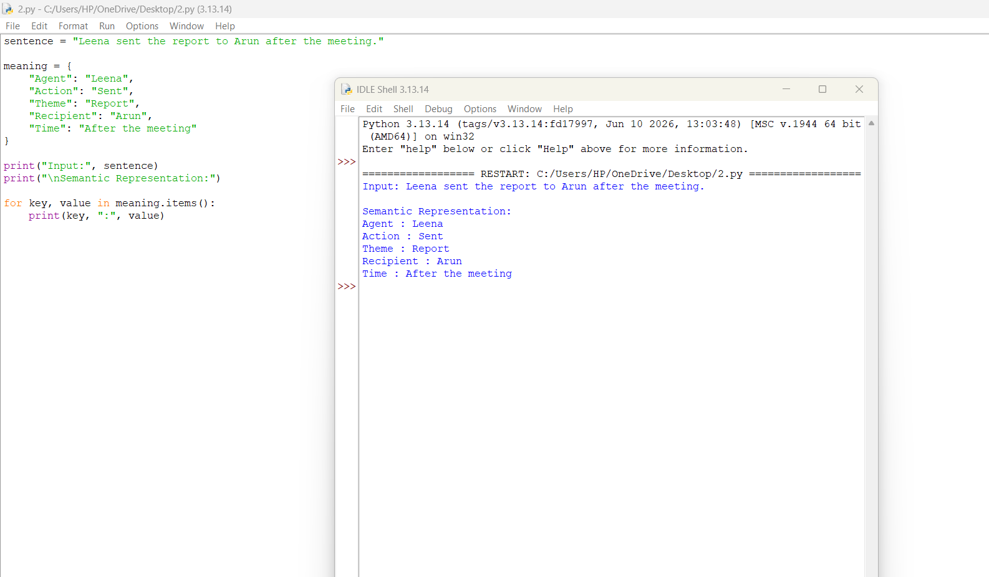
TASK 2 – FIRST ORDER PREDICATE CALCULUS: FORMALISE AND TEST
2.1 PREDICATE VOCABULARY
First Order Predicate Calculus represents natural language statements using predicates, variables, constants and logical symbols.
Predicates:
Predicate | Meaning
Learner(x) | x is a learner
Course(y) | y is a course
Enrolled(x,y) | x is enrolled in course y
Completed(x,y) | x completed course y
Prerequisite(x,y) | Course x is a prerequisite for course y
Constants:
- NLP – Natural Language Processing course.
- AI – Artificial Intelligence course.
- CSE – Computer Science department.
Variables:
- x – Learner
- y – Course
- z – Another course
2.2 FORMALISATION
(i) Every learner enrolled in NLP has completed at least one prerequisite.
Formula:
∀x [(Learner(x) ∧ Enrolled(x,NLP)) → ∃y (Course(y) ∧ Prerequisite(y,NLP) ∧ Completed(x,y))]
Explanation: Every learner enrolled in NLP must have completed at least one prerequisite course.
(ii) Some learner completed every course offered by the department.
Define:
OfferedBy(y,CSE) – Course y is offered by the CSE department.
Formula:
∃x [Learner(x) ∧ ∀y ((Course(y) ∧ OfferedBy(y,CSE)) → Completed(x,y))]
Explanation: At least one learner has completed all courses offered by the department.
(iii) No learner completed a course that they were not enrolled in.
Formula:
∀x∀y [(Learner(x) ∧ Course(y) ∧ Completed(x,y)) → Enrolled(x,y)]
Explanation: A learner can complete a course only if they are enrolled in it.
2.3 QUANTIFIER-SCOPE CHALLENGE
Consider:
∀x ∃y Enrolled(x,y)
Meaning: Every learner is enrolled in at least one course.
Modified Formula:
∃y ∀x Enrolled(x,y)
Meaning: There is one course in which every learner is enrolled.
Finite Model:
Learners: Asha, Ravi
Courses: NLP, AI
Enrollment:
- Asha → NLP
- Ravi → AI
Result:
The original formula is true because both learners are enrolled in a course.
The modified formula is false because there is no single course common to both learners.
Therefore, the two formulae are not logically equivalent.
2.4 CONSISTENCY TEST
Knowledge Base:
Facts:
- Learner(Asha)
- Course(NLP)
- Enrolled(Asha,NLP)
- Completed(Asha,NLP)
Rule:
∀x∀y [(Learner(x) ∧ Course(y) ∧ Completed(x,y)) → Enrolled(x,y)]
Query:
Is Asha enrolled in NLP?
Formula:
Enrolled(Asha,NLP)
Inference:
- The knowledge base directly contains Enrolled(Asha,NLP).
- Therefore, the query is true.
Result:
The query follows from the knowledge base.
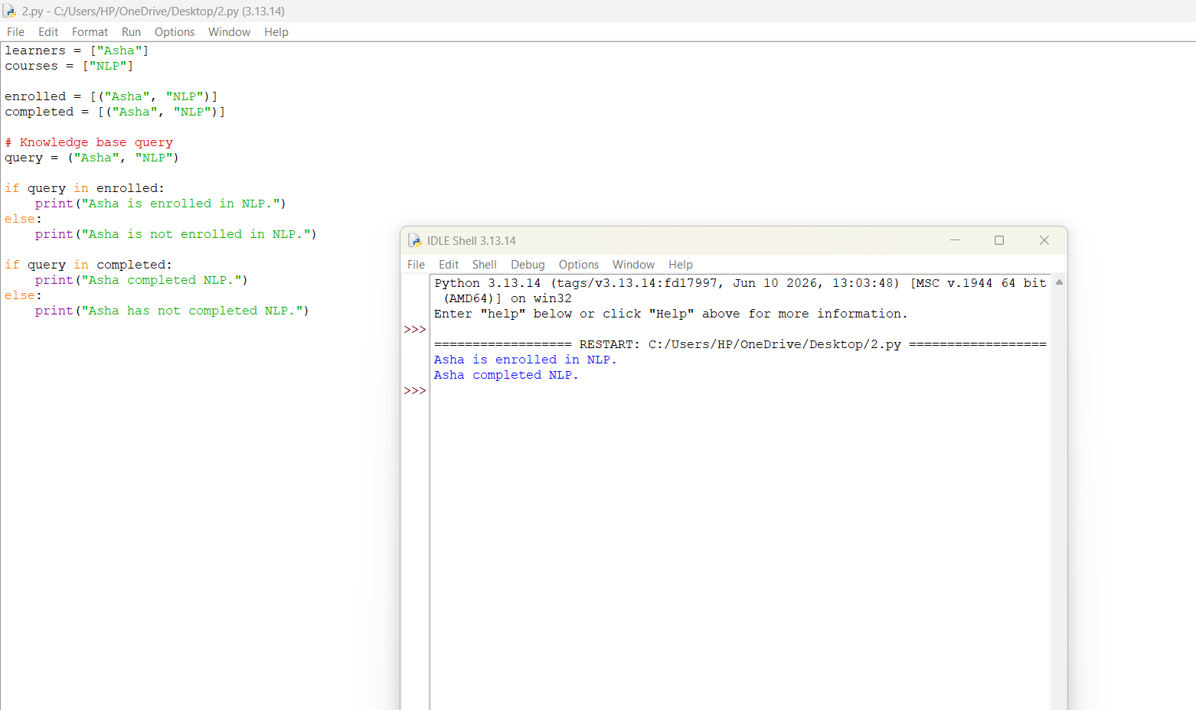
TASK 3 – LINGUISTIC CONCEPTS AND SYNTAX-DRIVEN SEMANTIC ANALYSIS
Given Sentence:
"The analyst noticed the student with the camera near the library."
3.1 LINGUISTICALLY RELEVANT CONCEPTS
Concept | Identification
Entity 1 | Analyst
Entity 2 | Student
Entity 3 | Camera
Entity 4 | Library
Action | Noticed
Modifier | The
Instrument | Camera
Location | Near the library
Main Relation | Analyst noticed student
Explanation:
The analyst is the person performing the action. The student is the person being noticed. The camera may be an instrument used by the analyst or an object possessed by the student. The library provides location information.
3.2 PARSE-TO-MEANING PROCEDURE
The sentence has two possible interpretations.
Interpretation 1 – Camera as an Instrument
The analyst used a camera to notice the student near the library.
Semantic Representation:
NOTICE (Analyst, Student)
USE (Analyst, Camera)
NEAR (Student, Library)
Procedure:
- Identify the subject as analyst.
- Identify the verb as noticed.
- Identify the object as student.
- Attach the phrase "with the camera" to the action.
- Identify the library as the location.
Interpretation 2 – Camera Belongs to the Student
The analyst noticed a student who had a camera near the library.
Semantic Representation:
NOTICE (Analyst, Student)
HAS (Student, Camera)
NEAR (Student, Library)
Procedure:
- Identify the subject as analyst.
- Identify the action as noticed.
- Identify the object as student.
- Attach "with the camera" to the student.
- Identify the location as near the library.
Point of Difference:
The interpretations differ when the phrase "with the camera" is attached either to the verb or to the noun student.
3.3 COMPOSITION AND TYPE / ROLE CHECKS
Semantic Composition:
- Analyst identifies the person.
- Noticed identifies the action.
- Student identifies the object.
- Camera provides additional information.
- Library provides location information.
Validation Checks:
- Check whether the instrument is connected to a suitable action.
- Check whether the location is correctly connected to the event or participant.
These checks help identify incorrect semantic relationships.
3.4 ERROR CHALLENGE
Example:
"The analyst noticed the student with the camera near the library."
A syntactically possible interpretation may incorrectly treat the library as the instrument used for noticing.
Expected System Response:
The system may produce an incorrect semantic relationship if it depends only on word attachment.
Improvement:
Use contextual information and selectional preferences to check whether the assigned roles are meaningful.
For example, a camera can be an instrument, while a library is normally a location.
TASK 4 – LEXEMES, SENSES AND WORD SENSE DISAMBIGUATION
4.1 LEXEME AND SENSE INVENTORY
A lexeme is the basic vocabulary unit representing a word. A word form is the actual form used in a sentence. A sense is the particular meaning expressed in a context.
Different Senses of LIGHT:
Sentence | Word Form | Part of Speech | Meaning
Turn on the light. | Light | Noun | Electrical illumination
This bag is light. | Light | Adjective | Not heavy
The light meal was served early. | Light | Adjective | Small or not heavy food
The same lexeme LIGHT can express different meanings depending on its grammatical use and surrounding words.
4.2 WSD DESIGN
Proposed Method: Rule-Based Word Sense Disambiguation
Input:
A sentence containing the word LIGHT.
Candidate Senses:
- Illumination.
- Not heavy.
- Small or less filling food.
Context Features:
- Nearby words.
- Part of speech.
- Verbs and nouns.
- Sentence meaning.
Decision Procedure:
- Read the input sentence.
- Identify the word LIGHT.
- Extract nearby words.
- Check the grammatical category.
- Compare context words with candidate meanings.
- Select the best matching sense.
- Display the result.
Output:
The selected meaning of LIGHT.
4.3 APPLY AND CHALLENGE
Test Examples:
Sentence | Context Evidence | Selected Meaning
Turn on the light. | Turn on | Illumination
This bag is light. | Bag, is | Not heavy
The light meal was served early. | Meal, served | Small meal
The room needs more light. | Room, needs | Illumination
Failure Case:
Example: "This is a light product."
The system may not identify whether LIGHT refers to low weight or a pale colour without additional context.
Improvement:
Use more surrounding words and sentence context to improve sense selection.
4.4 EVALUATION
Sample Labelled Test Set:
No. | Sentence | Correct Sense
1 | Turn on the light. | Illumination
2 | The light is very bright. | Illumination
3 | Switch off the light. | Illumination
4 | This bag is light. | Not heavy
5 | The box is light. | Not heavy
6 | She carried a light suitcase. | Not heavy
7 | We had a light breakfast. | Small meal
8 | They served a light dinner. | Small meal
Annotation Policy:
Each sentence is labelled according to its intended meaning. The surrounding context is used to assign the correct sense.
Suppose the system correctly predicts 7 out of 8 examples.
Accuracy Formula:
Accuracy = (Correct Predictions / Total Predictions) × 100
Accuracy = (7/8) × 100
Accuracy = 87.5%
Explanation:
Accuracy measures the percentage of correct predictions. However, class imbalance can affect the result. If most examples belong to one sense, the system may perform well on that sense but poorly on other meanings.
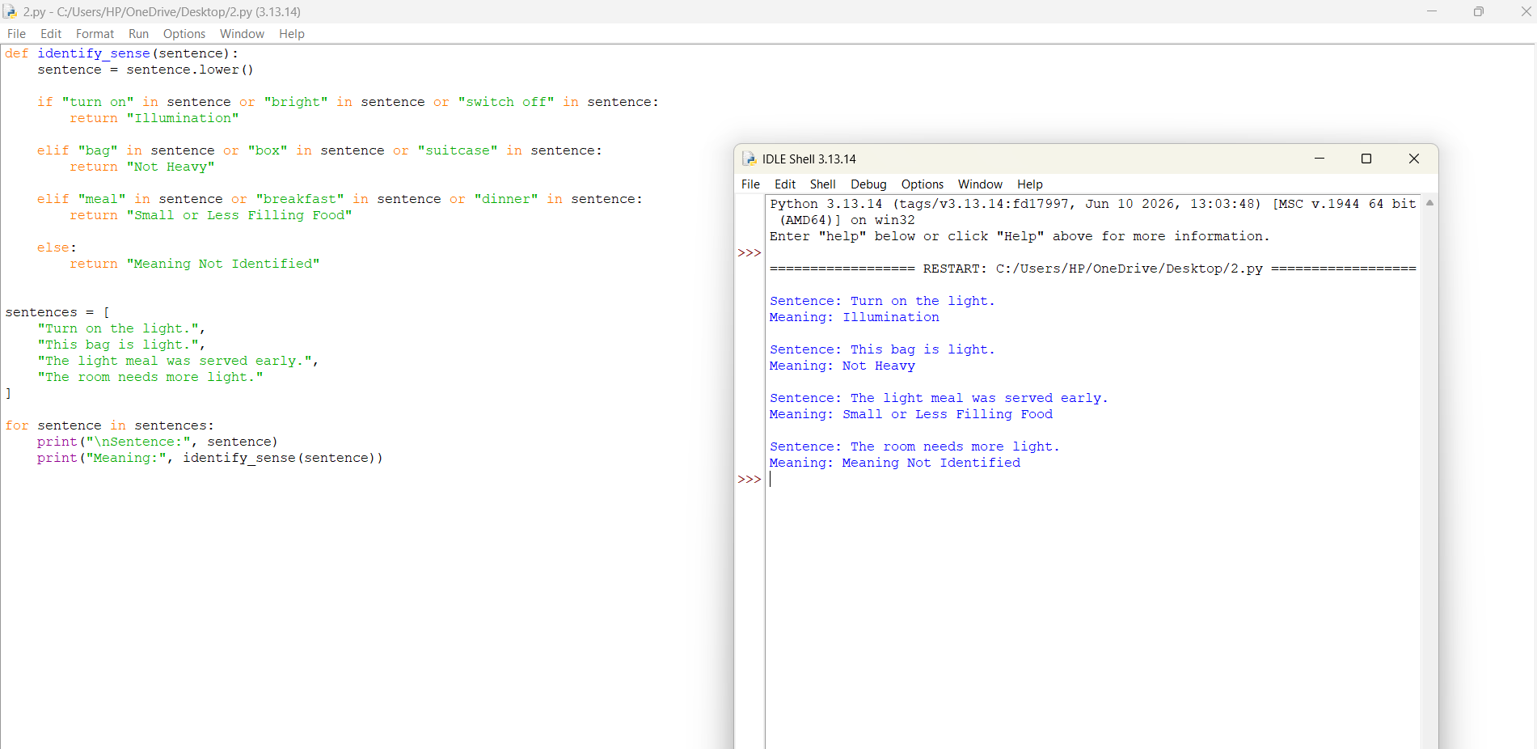
TASK 5 – SEMANTIC INFORMATION RETRIEVAL
5.1 QUERY AND DOCUMENT SEMANTICS
Given Query:
"How can a system identify the intended meaning of a word in context?"
Main Concepts:
- Word meaning
- Context
- Word Sense Disambiguation
- Semantic analysis
- Language processing
Query Representation:
Q = {Word Meaning, Context, WSD, Semantic Interpretation}
Candidate Documents:
Document | Description | Actual Relevance
D1 | Word Sense Disambiguation using Context | Relevant
D2 | Contextual Meaning Identification in NLP | Relevant
D3 | Dictionary of English Words | Partially Relevant
D4 | Word Frequency Calculation | Not Relevant
D5 | Semantic Analysis and Meaning Extraction | Relevant
The documents contain different words but may discuss the same central concept.
5.2 RANKING STRATEGY
The system uses two important signals:
- Lexical Similarity – Measures matching words.
- Semantic Similarity – Measures similarity between meanings.
Ranking Formula:
Final Score = (0.3 × Lexical Similarity) + (0.7 × Semantic Similarity)
Semantic similarity receives a higher weight because the search system focuses on meaning.
Tie Handling:
If two documents receive the same score, the system gives priority to the document with better concept coverage.
5.3 RETRIEVAL TRACE
Example Scores:
Document | Lexical Score | Semantic Score | Final Score
D1 | 0.9 | 0.9 | 0.90
D2 | 0.5 | 0.9 | 0.78
D3 | 0.8 | 0.4 | 0.52
D4 | 0.7 | 0.2 | 0.35
D5 | 0.6 | 0.9 | 0.81
Ranking:
- D1 – 0.90
- D5 – 0.81
- D2 – 0.78
- D3 – 0.52
- D4 – 0.35
Explanation:
D2 receives a good score even though its lexical similarity is low because its meaning matches the query.
D4 contains related keywords but does not answer the actual question.
5.4 EVALUATION
Assume the relevant documents are D1, D2 and D5.
At the top 4 cutoff:
- Retrieved documents = 4
- Relevant retrieved documents = 2
- Total relevant documents = 3
Precision:
Precision = Relevant Retrieved / Total Retrieved
Precision = 2/4
Precision = 50%
Recall:
Recall = Relevant Retrieved / Total Relevant
Recall = 2/3
Recall = 66.67%
False Positive:
D3 is a false positive because it is related to words but does not explain the intended meaning in context.
False Negative:
D5 is a false negative at the top 4 cutoff? No. It is ranked fifth, so it is not retrieved in the top four. Therefore, D5 is a false negative.
Improvement:
Increase semantic similarity checking and improve the ranking method so that relevant documents receive higher positions.
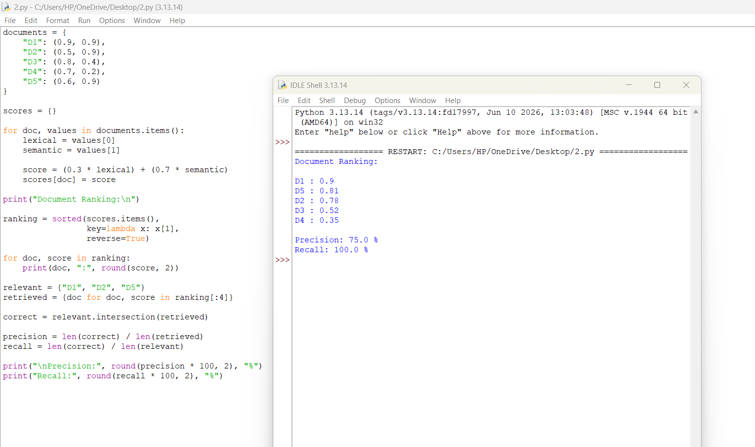
TASK 6 – INTEGRATED SEMANTIC ANALYSIS DESIGN CHALLENGE
Given Sentence:
"I watched the crane by the bank, then it moved."
6.1 MODEL THE AMBIGUITY
The sentence contains two ambiguous words.
Possible Meanings:
- Crane may refer to a bird or a construction machine.
- Bank may refer to a financial institution or a river side.
- It may refer to the crane or the bank.
Required Context:
The system needs information about the surrounding environment, nearby objects and the action being described.
6.2 CANDIDATE MEANING STRUCTURES
Interpretation 1 – Crane as a Bird
Meaning:
The speaker watched a bird near the river bank, and the bird moved.
Semantic Roles:
- Agent: Speaker
- Action: Watched
- Object: Crane (Bird)
- Location: River Bank
- Movement: Bird moved
Structured Representation:
WATCH (Speaker, CraneBird)
NEAR (CraneBird, RiverBank)
MOVE (CraneBird)
Interpretation 2 – Crane as a Construction Machine
Meaning:
The speaker watched a construction crane near a bank building, and the machine moved.
Semantic Roles:
- Agent: Speaker
- Action: Watched
- Object: Crane (Machine)
- Location: Financial Bank
- Movement: Crane moved
Structured Representation:
WATCH (Speaker, CraneMachine)
NEAR (CraneMachine, FinancialBank)
MOVE (CraneMachine)
6.3 SYNTAX AND WSD TRACE
Procedure:
- Identify the subject as the speaker.
- Identify the action as watched.
- Identify CRANE as an ambiguous noun.
- Generate bird and machine meanings.
- Identify BANK as another ambiguous noun.
- Generate financial and geographical meanings.
- Use the surrounding context to select suitable meanings.
- Resolve the pronoun IT using the previous sentence structure.
Contextual Evidence:
- Words such as wings, feathers and flying support the bird meaning.
- Words such as construction, building and machinery support the machine meaning.
- Words such as river, water and shore support the geographical meaning of bank.
If the context is insufficient, the system should retain alternative meanings or ask the user for clarification.
6.4 SEMANTIC RETRIEVAL
Assumption:
The intended meaning is a construction crane near a financial bank building.
Query Representation:
{Construction Crane, Machine Movement, Crane Operation, Financial Building}
Candidate Documents:
Document | Description | Relevance
D1 | Construction Crane Movement and Operation | High
D2 | Safety and Operation of Lifting Machines | High
D3 | Crane Birds and Their Natural Habitat | Low
D4 | Different Types of River Banks | Low
Ranking:
- D1 – Construction Crane Movement and Operation.
- D2 – Safety and Operation of Lifting Machines.
- D3 – Crane Birds and Their Natural Habitat.
- D4 – Different Types of River Banks.
Explanation:
The system selects documents related to construction machinery because the selected sense of CRANE is a machine.
It avoids documents about crane birds and river banks because they do not match the intended interpretation.
6.5 ADVERSARIAL REFINEMENT
Misleading Context:
Suppose the sentence is:
"I watched the crane by the bank, then it moved near the water."
The system may incorrectly identify the crane as a construction machine because it is strongly associated with building activities.
However, the phrase "near the water" may support the bird interpretation.
Expected Result:
The system should compare all contextual clues before selecting the meaning.
Improvement:
Use contextual similarity, grammatical relationships and semantic role checking together. This reduces incorrect word sense selection and improves document retrieval.
CONCLUSION
This assignment demonstrates how semantic systems analyse natural language, represent meaning and resolve ambiguity. It covers event representation, first-order predicate calculus, syntax-driven semantic analysis, word sense disambiguation and semantic information retrieval. Different representations and test examples show how an NLP system can identify intended meanings and retrieve suitable information. Testing and evaluation help identify errors and improve the reliability of semantic processing systems.



